Assimila Datacube plugin v2.0 users guide

Contents

Download QGIS 3.8.1 (3.4.10 LTR) for Windows 2

Importing the plugin 4

Importing modules in QGIS default environment 5

Importing third-party modules 5

Module(s) to be imported 5

How to use the plugin 6

Useful plugins to be installed 12

How to install existing plugins 12

# Download QGIS 3.8.1 (3.4.10 LTR) for Windows

1. Go to <https://www.qgis.org/en/site/forusers/download.html>
2. Download the relevant one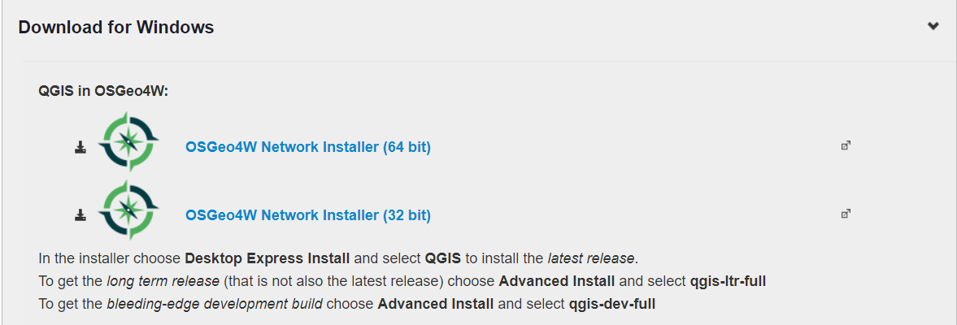
3. Run the .exe file downloaded. Accept all defaults and terms and conditions.
4. Select download from <http://download.osgeo.org>

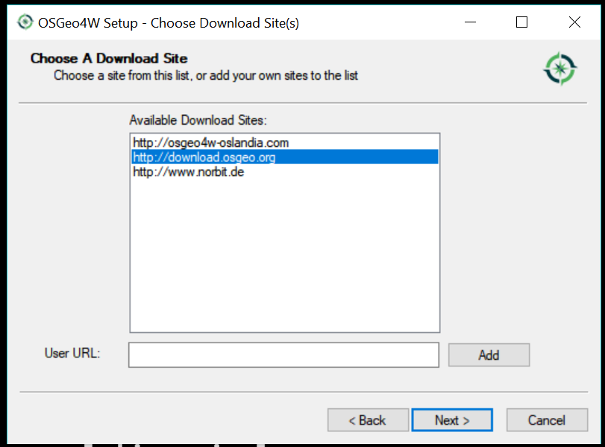

1. Select the packages: ‘QGIS’, ‘GDAL’, and ‘GRASS GIS’.

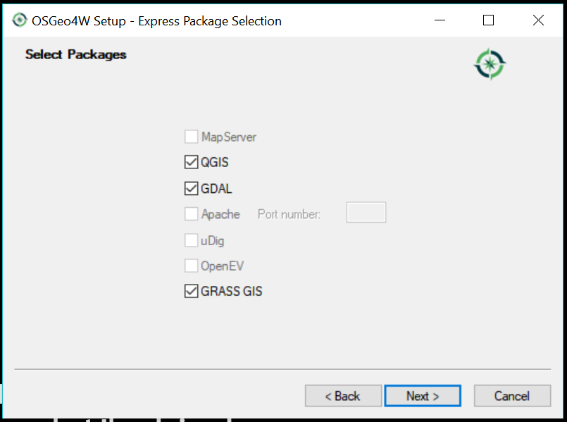

1. Accept all license terms.

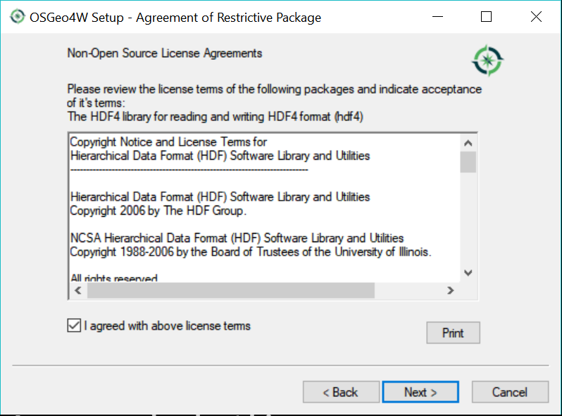

1. This process will take around 10 minutes. Once installed the user can open QGIS.

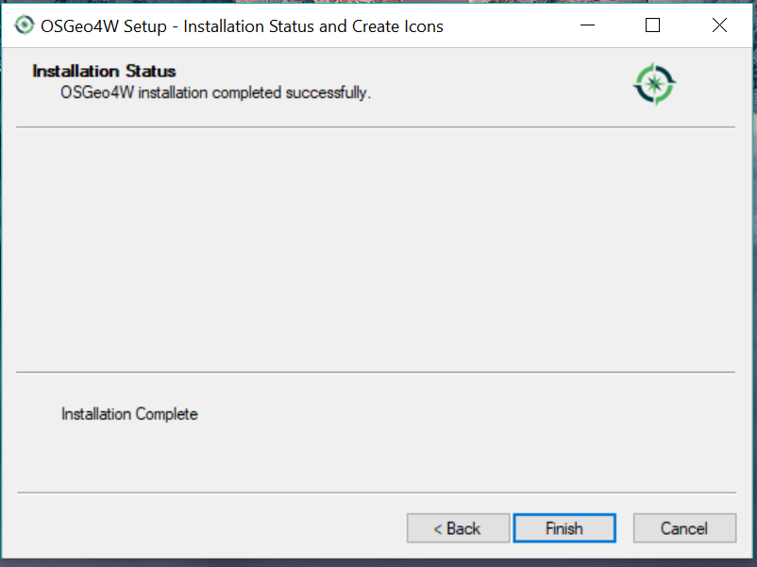

# Importing the plugin

To import the local existing plugin, unzip the given file, and copy the directory of the plugin over to the QGIS plugins directory: C:\Users\USER\AppData\Roaming\QGIS\QGIS3\profiles\default\python\plugins

Then reload QGIS, Plugins > Manage and Install Plugins… > Installed and then check the plugin wanted.

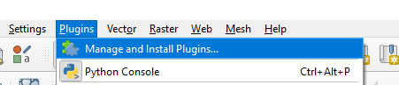

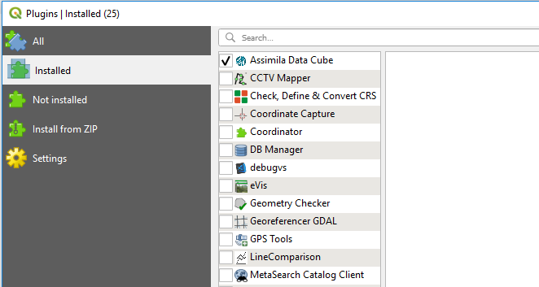

The plugin icon should then appear on the toolbar.

# Importing modules in QGIS default environment

## Importing third-party modules

1. Open “OSGeo4W Shell” and “Run as Administrator”. This opens up the default environment that QGIS runs on.

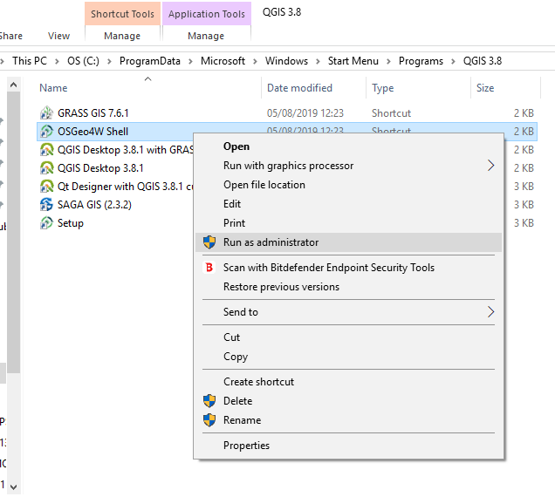

1. Run python -m ensurepip --default-pip



1. The default python is version 2, so to change to version 3: run py3_env

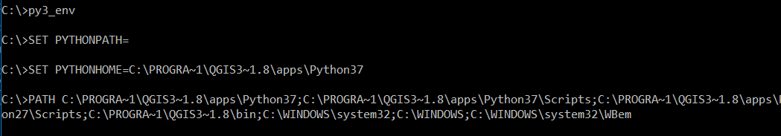

1. Run python to check version
2. Run python -m pip install <module__name> (let module_name = ‘xarray==0.10.4’ instead of ‘xarray’)

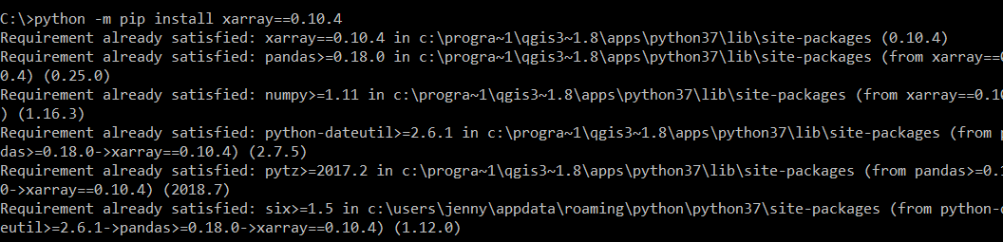

1. To check if it has been imported, in python console of QGIS run import xarray
2. To check the version of the xarray run xarray.__version__ into python console in QGIS
3. To uninstall: python -m pip uninstall <module_name>

## Module(s) to be imported

* pip install xarray ==0.10.4
* pip install pyshp

# How to use the plugin

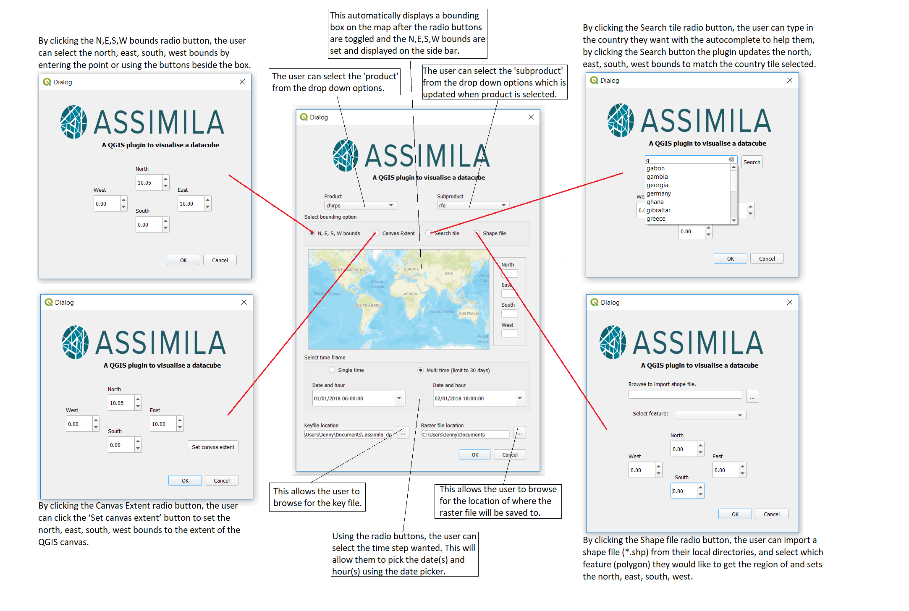

1. From the toolbar, click the Assimila datacube plugin to run plugin. 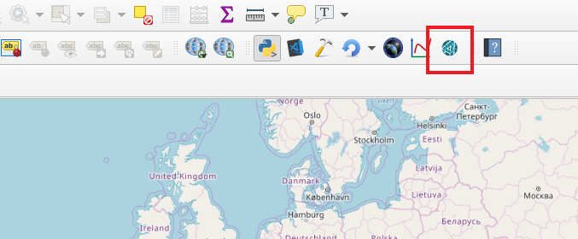
2. Select from dropdown menu a Product.
3. Select from dropdown menu a Subproduct of that Product.
4. The user can select the method to enter the north, east, south and west point using the radio buttons which will open a pop-up window.

* The first radio button- ‘N, E,S, W coordinates’ allows the user to input the bounds manually.
* The second radio button – ‘Set Canvas Extent’ sets the points as the dimension of the canvas. There is a set limit for the area which was set to 25x25=626 degrees so QGIS will not crash.
* The third radio button – ‘Search Tile’ allows the user to input a tile region (e.g. Ghana), and performs a search to find the bounds if they exist. The search bar also has autocomplete.

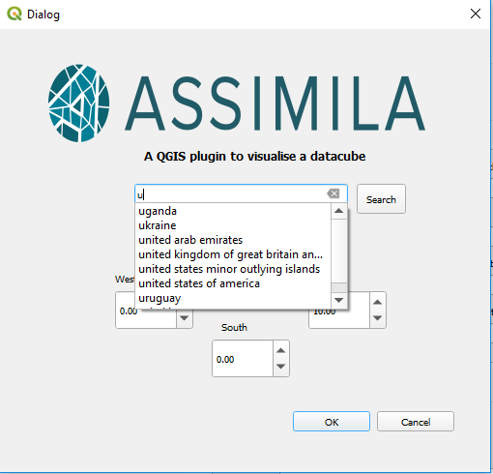

* The fourth radio button – ‘Shape file’ allows the user to select which shape file (*.shp) to import, and select which feature(polygon) they want to read the N, E, S, W bounds from.

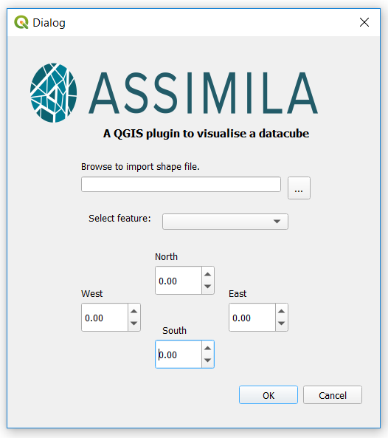

Once the ‘OK’ button on the pop-up windows are clicked, then this closes the pop-up window, and displays a box on the map displaying the tile of area selected. The north, east, south, west bounds are also displayed in the side bar beside the map. The user can change the bounds by re-toggling the radio buttons.

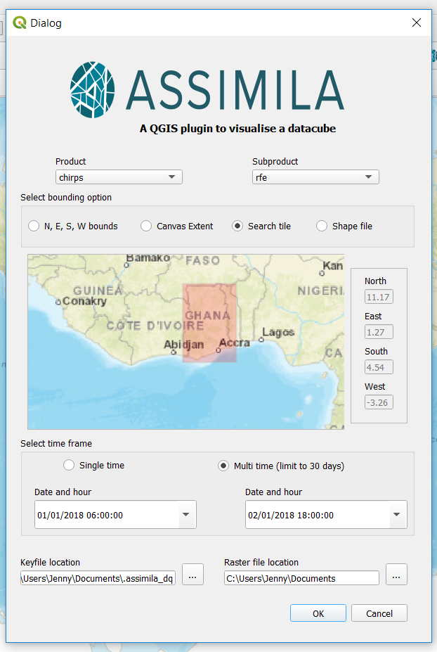

1. The user can select from the single time or multi time radio buttons, and select the date and hour accordingly. (For multi time, the maximum difference in days is 30 days 23 hours)
2. The user must have a key file which the default location is the user’s document folder, the user can change the directory by pressing the toolbox beside it.
3. By clicking ‘OK’ it will run the program with the above parameters, and display a raster file.
4. Once the process is run, the user will have the raster image on top of the map where you can see the location.

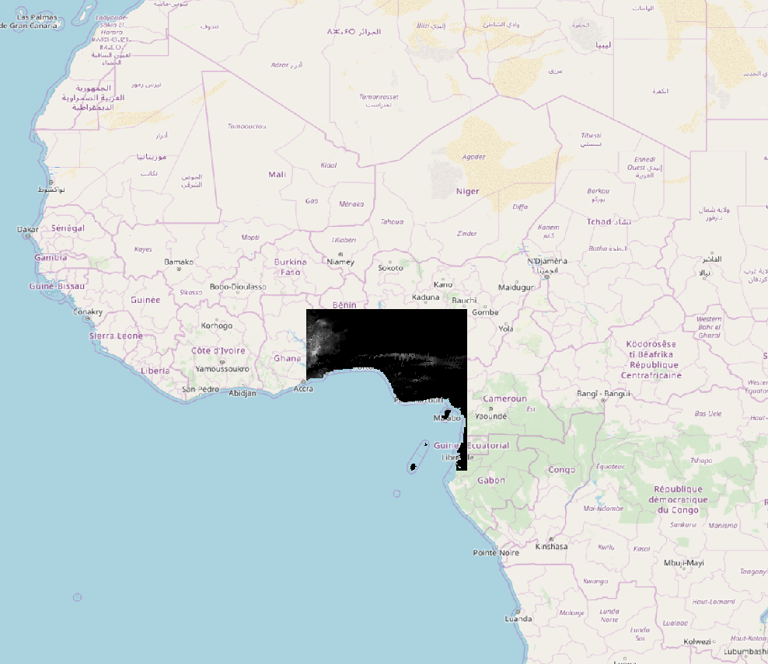

1. If the user has imported the ‘Digitizing Tools’ plugin, the plugin can read a shapefile:
2. Open ‘Digitizing Tools’ plugin, go to Layer > Add Layer > Add Vector Layer 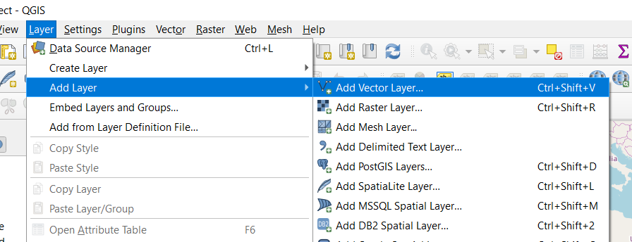
3. Find the relevant shapefile to import to QGIS, and click ‘Add’ which will add the features of the shapefile to the canvas. 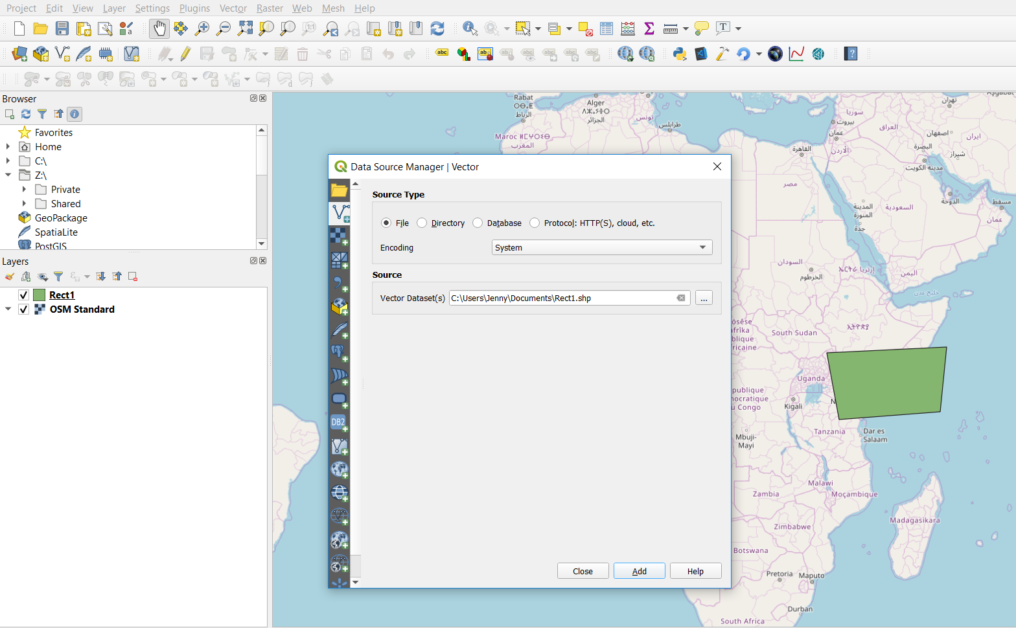
4. To create a new shapefile to draw the polygon:
   * + 1. Open ‘Digitizing Tools’ plugin, click ‘New Shapefile Layer’. Enter filename including location path (or browse directory for location path). Set Geometry type to be ‘Polygon’. For the Additional Dimensions drop down menu, select ‘Default CRS: ESPG:4326 – WGS 84’ and click ‘OK’.

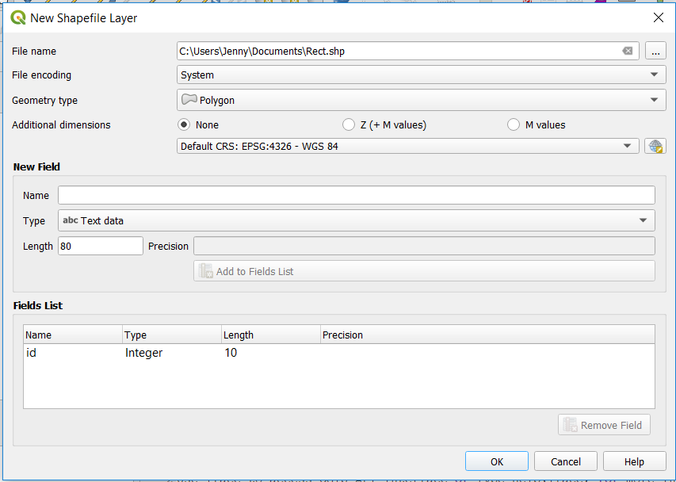

* + - 1. Once the shapefile is created, right click on the shapefile layer, and then go to Toggle Editing. From the toolbar at the top, select the ‘Add Polygon Feature’ icon.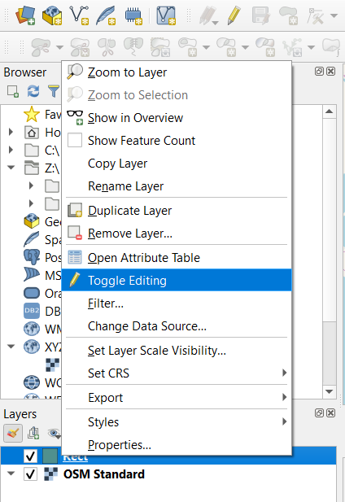 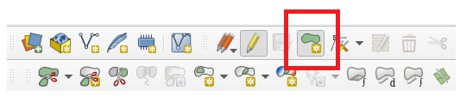
      2. Draw the polygon, and right click to finish. A pop up window asking for ID is displayed to enter the ID which will be used to identify and select that specific polygon feature. Save the layer, and this can be removed before plugin.

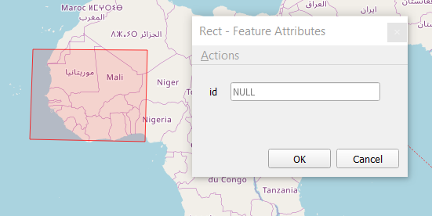

* + - 1. Then run the plugin as usual, and click the ‘Shape file’ radio button, and importing that shapefile and then selecting that feature id from the drop down. The raster image should create a layer on top of the Shape file created. 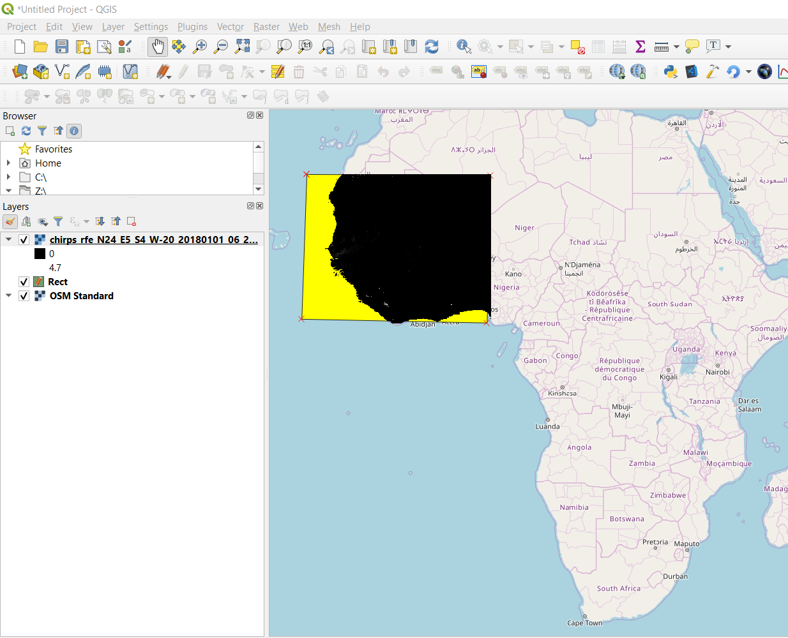

# Useful plugins to be installed

The following plugins can be installed and be used in conjunction with the plugin.

- QuickMapServices

- Temporal/Spectral Profile Tool

- Digitizing Tools

## How to install existing plugins

To install published plugins on QGIS, go to Plugins > Manage and Install Plugins… The user can either search the plugin’s name or install from zip file (which can be downloaded from the QGIS Python Plugins Repository <https://plugins.qgis.org/plugins/>)



